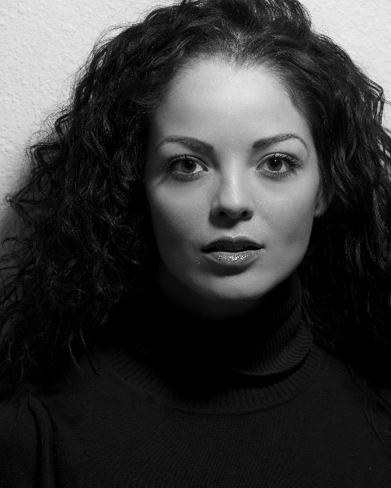
Talent Resume
Julia Rae Gallegos
Physical Information

Height 5' 7"
Weight 120 lbs.
Age Range 25-35
Ethnicity Hispanic/Latino
Eye Color Brown
Hair Color Black
Hair Length Lower Back
Build Slender
Dress 3
Bust 35
Cup DD
Waist 27
Hips 35
Ring 4.5
Shoe 7
Shirt/Top Small

FILM
The Last Stand FBI Tactical Agent
Fright Night Club Lesbian
Assumptions Kate
Dement Wife
The Last Appointment Death
Busking For Broke Zora the Gypsy
Prescription Earth Patient
Bravo Romeo Oscar Natalie Brazil

Music Video
Whiskey In A Glass Lead Actor

TV
Vegas ~ CBS Showgirl
In Plain Sight ~ USA Market Vendor
Zero Hour Squared TV Show Guest Host
UTMI Commercial Massage Therapist
Stash Pipe Commercial Teenager
Rent an ATV Commercial Bikini clad rider
Beyond Computers Commercial Computer Technician
Elisa’s Salon Commercial Customer

VOICEOVER
Buck & Dex Morning Show Stunt Girl Clear Channel
DACC Commercial Voice DACC

PRINT

El Paso Times – Cover
La Loca Magazine - Cover
Weekly Alibi - Cover
Billboard for NMSU
Lucy B Pin-Up of the Month
Circa Espresso Bar Ad
Historic Route 66 Motel Ad
Quay Sun - Cover
Motel Safari A Route 66 Classic Ad
Pinup-ology Ad
12 Facts About New Mexico Women
La Loca Magazine - Centerfold
My 5 Finds (Featured in ABQ Mag)
Beauty Book 2012
DCD Ad in ABQ Mag
2012 Savio Catalog
Mary Kay
Indian Market Ad
Nerd Poster for Comicon
Billboard for Enchantment Car Show
66 Pin-Ups Calendar
Beyond Fantasy Magazine - Cover
Albuquerque The Magazine
Duke City Magazine
Fast Eddie's Hotrods
Color Me Sexy Calendar - Cover
Lightening Auto Calendar
Dan Griggs Fine Art
Duke City Darlins Calendar
Inspire Salon Ad
Full Circle Wellness Ad
Beyond Fantasy Calendar
DCD "Best Humanitarian"
Best Of The City (ABQ Mag)
Bikini Coffee Co
DCD Magnet Calendar
Warrior Run Promotion

LIVE EVENT/PROMOTION

Ann Taylor Model
Adult Swim Funhouse Tour
Patricia Michaels Runway Model
Rockabilly On The Route
66 Pin-Ups Promo Model
La Loca Magazine Release
ABQ's Top Model
Centerfold Live Signing
PlayerXT Tournament with Playmates
Face To Face Networking Host
Dust N Rust Car Show
Casa Esencia Masquerade Ball
Montezuma Ball
Big Orange Promotions
AudioAir Premier
Albuquerque Gay Pride Parade
Bar S Rodeo
Doubletree Superhero Fundraiser
Dia De Los Muertos Fundraiser
Body Paint Allure Grand Opening Warrior Run & After Party Host
Octoberfest Beer Wench
Doubletree Dia De Los Muertos Party
L’Oréal Presents Cosmo on Campus
Pinup-Ology “The Science of a Pin-Up”
Club 405 Spokesmodel
Indian Market Santa Fe
Sinful Solstice
Rock The Ink
Bumble & Bumble Hair Model
Run For The Cure
SubPop Culture
Dia De Los Muertos Parade
Ronald McDonald House
Face To Face Fashion Show
94 Rock Calendar Review
Ammunition Latex Model
The Designers Lounge Model
Inspire Salon Hair Model
Craft Punk Fashion Show
Generate Fashion Show
Albuquerque Comicon
Doubletree Oscar Party
Chical Live Mannequin
American Harvest Vodka
Miss Cannabis

AWARDS
Albuquerque's Top Model Elltography/Q-Bar
Best Humanitarian Albuquerque The Magazine
Miss Dia De Los Muertos Rock The Ink

SPECIAL SKILLS: OTHER
NRA certified Pistol Instructor Massage Therapist Training
Film Writer/Director/Producer I’m a professional photographer

AUTOMOBILES
Ford Mustang, 2004, Red/Maroon, convertible

